Work Instructions

For Raspberry Pi

IC-INF-IT1H

Table of contents

## **How to set up a Raspberry Pi**

**How to install and set up the PiCamera**

**How to install the NFC ACR122u**

**How to install the rest of the libraries for the Raspberry pi**

**How to run the application**

This document is about how to install the libraries and how to be able to run the code for the Raspberry Pi application.

## **How to set up a** **Raspberry Pi**

1. What do you need:

* You will need an external mouse and keyboard and an SD card.

-The mouse and the keyboard are for to access and be able to set the Raspberry Pi when you are installing the OS.

-The SD card is to install the OS on it.

1. Download The OS:

* On your laptop insert the SD card and download the Operation System from: https://www.raspberrypi.com/software/

1. Set up the Screen:

Step 1: Setting Up the Touchscreen to the Raspberry Pi.

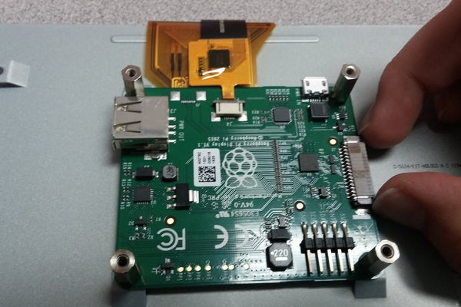

Step 2: Connect Wires.

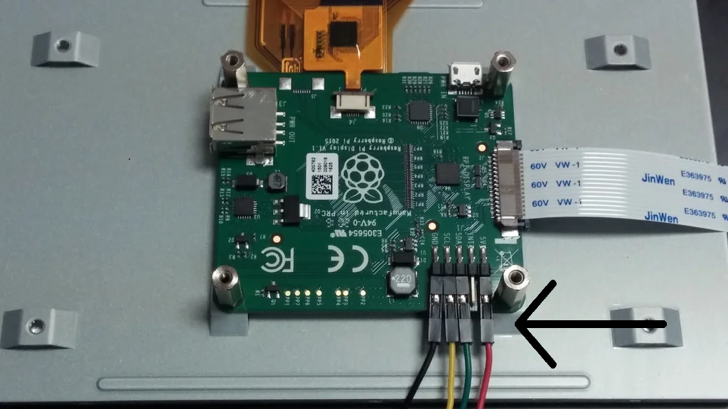

* + GND (Black)
  + 5V (Red)
  + SCL (Yellow)
  + SDA (Green)

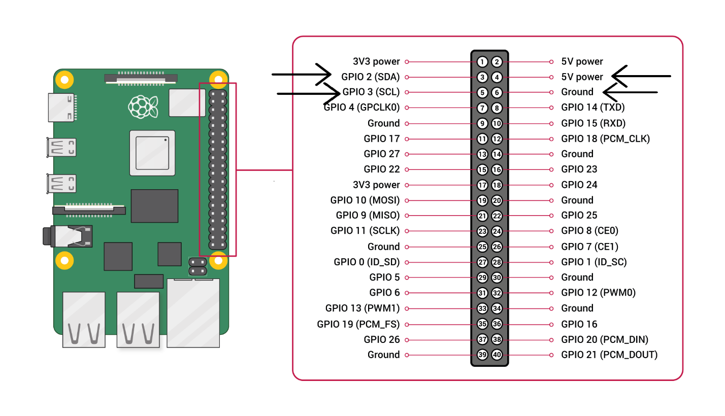

For a better understanding please look up on this link: <https://www.instructables.com/Raspberry-Pi-Touchscreen-Setup/>

1. Install the OS on the Raspberry PI.

* Click Next to start the setup.

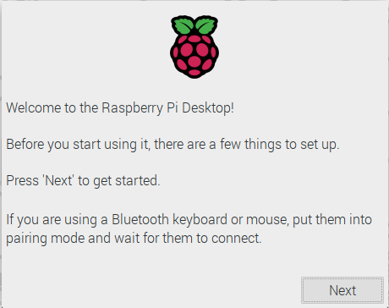

* Set your Country, Language, and Timezone, then click Next again.

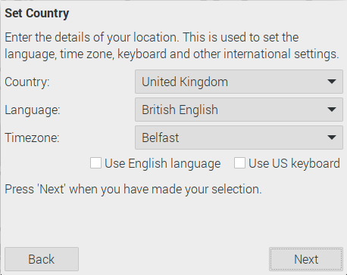

* Enter a new username and password for your Raspberry Pi and click Next.

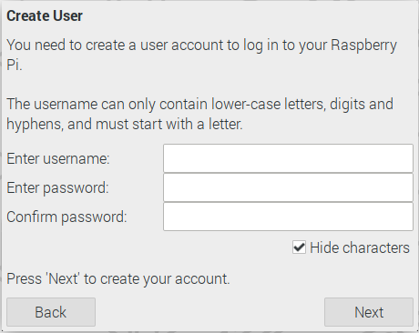  
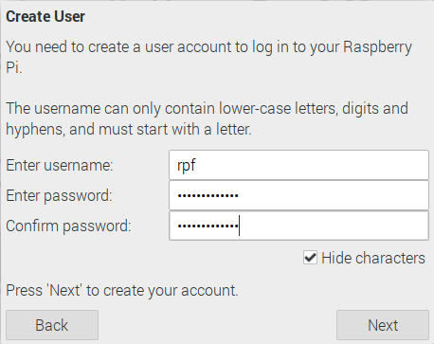

* Set up your screen or screens.

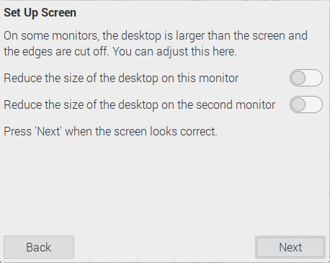

* Connect to your WiFi network by selecting its name, entering the password, and clicking Next.

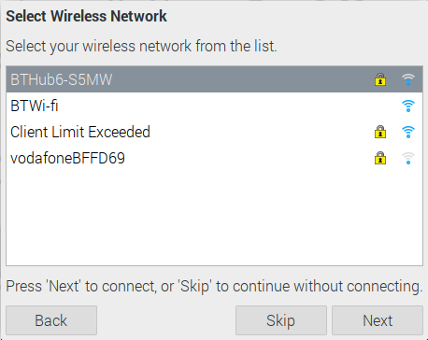  
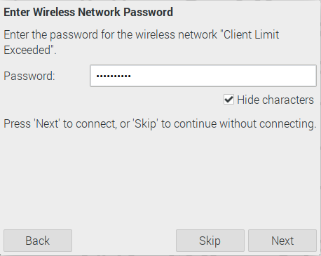

Note: If you want to connect to the EDUROAM WIFI you need to skip the internet and update’s part. (Down below you will find an explanation how to connect to it.)

* Click Next, check for updates to Raspbian and install them (this might take a little while).

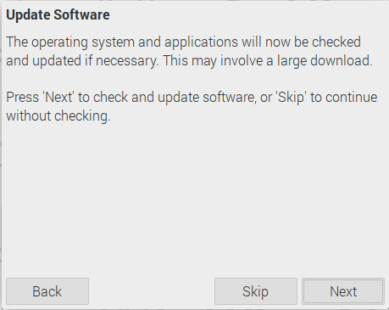

* Click Restart to finish the setup. For a better

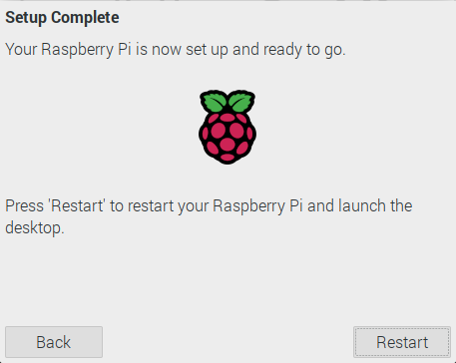

For a better understanding follow the link: https://projects.raspberrypi.org/en/projects/raspberry-pi-getting-started/4

5. Connect to the EDUROAM WIFI.

* + - 1. First click on the WIFI Icon.

* + - 1. Go to Advanced Options.

* + - 1. Click on Edit Connections..

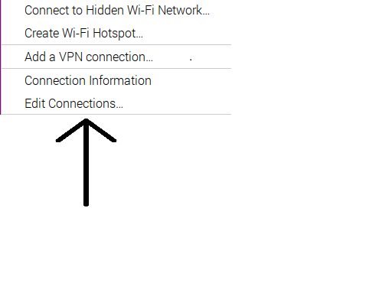

* + - 1. Select Eduroam

5. Go to WIFI Security

6. Fill in with the same settings and your student details.

7. Press save and now the WIFI Works :) (After this you can install the Updates).

**How to install and set up the PiCamera**

1. In this video you can see how exactly the PICamera should be connected.



2. Start up your Raspberry Pi.

* Go to the main menu and open the **Raspberry Pi Configuration** tool.

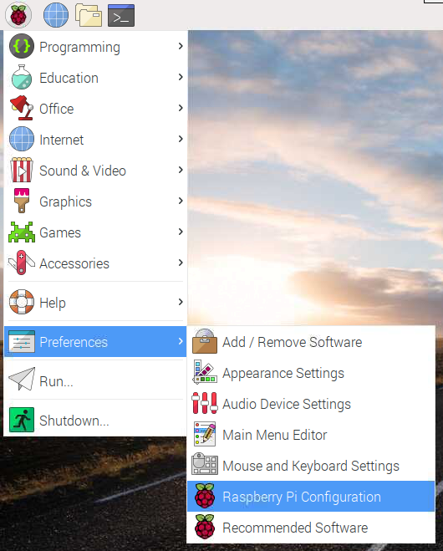

* Select the **Interfaces** tab and ensure that the camera is **enabled**:

Raspberry Pi Configuration Tool with the Interfaces menu opened and Camera enabled

* Reboot your Raspberry Pi. (If you don’t see the camera here, don’t worry sometimes it is not appearing.)
* https://projects.raspberrypi.org/en/projects/getting-started-with-picamera/2

3. Install the Picamera library.

* Open the terminal and write one by one:

sudo apt-get update

sudo apt-get upgrade

sudo apt-get install python-picamera python3-picamera

<https://picamera.readthedocs.io/en/release-1.13/install.html>

4. Install the libraries for Facial Recognition.

* For CV2:

pip install opencv-python

<https://pypi.org/project/opencv-python/>

* For Dlib:

Step #1: Update swap file size, boot options, and memory split

Increase swap file size

sudo nano /etc/dphys-swapfile

Scroll down to the configuration which reads: CONF_SWAPSIZE=100 -> CONF_SWAPSIZE=1024

And then update it to use 1024MB rather than 100MB:

After you have updated the /etc/dphys-swapfile file, run the following two commands to restart the swap service:

sudo /etc/init.d/dphys-swapfile stop

sudo /etc/init.d/dphys-swapfile start

Change your boot options

Boot Options => Desktop / CLI => Console Autologin:

To accomplish this, execute:

sudo raspi-config

Restart your Raspberry Pi

Upon exiting, raspi-config will ask if you would like to reboot your system.

Go ahead and reboot, then we can move on with the rest of the install tutorial

Step #2: Install dlib prerequisites

The dlib library requires four prerequisites:

Boost Boost.Python CMake X11 These can all be installed via the following commands:

sudo apt-get update

sudo apt-get install build-essential cmake

sudo apt-get install libgtk-3-dev

sudo apt-get install libboost-all-dev

Step #3: Access your Python virtual environment (if you are using them)

Using Python’s virtualenv and virtualenvwrapper libraries, we can create separate Python environments for each project we are working on — this is considered a best practice when developing software in the Python programming language.

If you would like to install dlib into a pre-existing Python, virtual environment, use the workon command:

While this command will create a Python 3 virtual environment named py3_dlib : mkvirtualenv py3_dlib -p python3

Step #4: Use pip to install dlib with Python bindings

I'm using python3

pip3 install numpy

pip3 install scipy

pip3 install scikit-image

pip3 install dlib

Step #5: Test out your dlib install

python3

Python 3.6.9 (default, Nov 7 2019, 10:44:02)

[GCC 8.3.0] on linux

Type "help", "copyright", "credits" or "license" for more information.

>>> import dlib

>>>

Step #6: Reset your swap file size, boot options, and memory split

Important — before you walk away from your machine, be sure to reset your swap file size to 100MB

For clear and better tutorial please refer to below page:

https://pyimagesearch.com/2017/05/01/install-dlib-raspberry-pi/

**How to install the NFC ACR122u:**

1. For the NFC is easier, first just connect the NFC to one of the USB ports.

2. Install the libraries for the NFC:

* sudo apt-get install pcscd libusb-dev libpcsclite1 libpcsclite-dev dh-autoreconf
* sudo pip install nfcpy

How to install the Servo Motor:

1. Connect the wires

* + GND (Brown)
  + 5V (Red)
  + SCL (Orange)

2. Install the library

* sudo apt-get update
* sudo apt-get install pigpio python-pigpio python3-pigpio

<https://abyz.me.uk/rpi/pigpio/download.html>

**How to install the rest of the libraries for the Raspberry pi**

**-all libaries are installed from the terminal**

**PYQT5**

* **sudo apt install python3-pyqt5**

[**https://www.pythonguis.com/installation/install-pyqt5-raspberry-pi/**](https://www.pythonguis.com/installation/install-pyqt5-raspberry-pi/)

**Numpy**

* **pip install numpy**

[**https://numpy.org/install/**](https://numpy.org/install/)

**SQLAlchemy**

* **pip install SQLAlchemy**

[**https://pypi.org/project/SQLAlchemy/**](https://pypi.org/project/SQLAlchemy/)

**How to run the application**

1. Open the VS Code

2. Select the “RaspberryPiApp” folder from Documents

3. Select the file main.py and run it